Colin Woelfel

April Flynn

Composing Digital Media

2 October 2020

Soundscape Reflection

Originally, I envisioned my soundscape as a medley of “real world” and computer-generated sounds. The goal was to place the listener in an environment they were familiar with, while interjecting more abstract sounds to provide a distinct ambiance. I thought a good way to go about doing this was to think of the project as a collection of the sounds you may hear in a virtual reality game-specifically one centered around nature.

I ultimately titled my piece “A Digital Environment”-which refers, in part, to the many technologies I used in creating this soundscape. To begin this project, I searched several pages of the internet to find the appropriate clips for this piece. Using an app on my phone, I also recorded sounds of my own. Then, I proceeded to use the program Audacity on my laptop to arrange and edit all the different sounds. All these tools comprise a “digital environment”, where the end-product, or soundscape in this case, is formed.

The term “digital environment” also has a second meaning here, referring to the substance of the piece. The soundscape begins with a clip of a computer turning on, signaling to the user that they are interacting with some form of technology. However, this sharply contrasts with sounds of rain and chirping birds that play immediately after. This juxtaposition continues throughout the piece, as the listener encounters abstract static sounds and glitch noises, followed by thunder and dripping of water in a cave. I intentionally made these choices to literally create a “digital environment”-a space that is computer generated, but still contains elements of the “natural world” we are familiar with.

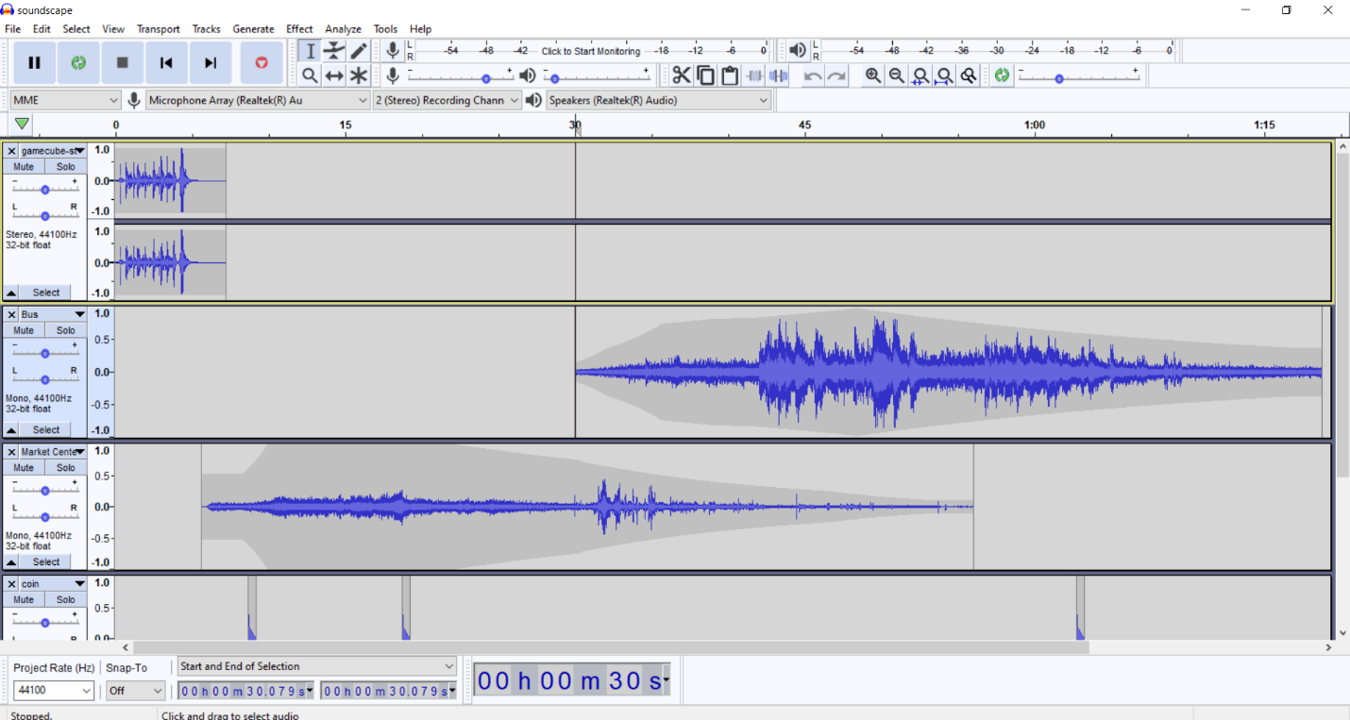

*Figure 1: Screenshot of First Draft Audacity File*

For the first iteration of my soundscape (pictured in Figure 1) the sounds of the “real world” were primarily clips I recorded on a bus ride in the city. I layered this with a few “retro” video-game sounds, such as a clip of a coin being collected. The issue with this version is that it did not accurately convey the environment I had in mind. The computer-generated sounds seemed out of place and did not contribute to the narrative progression.

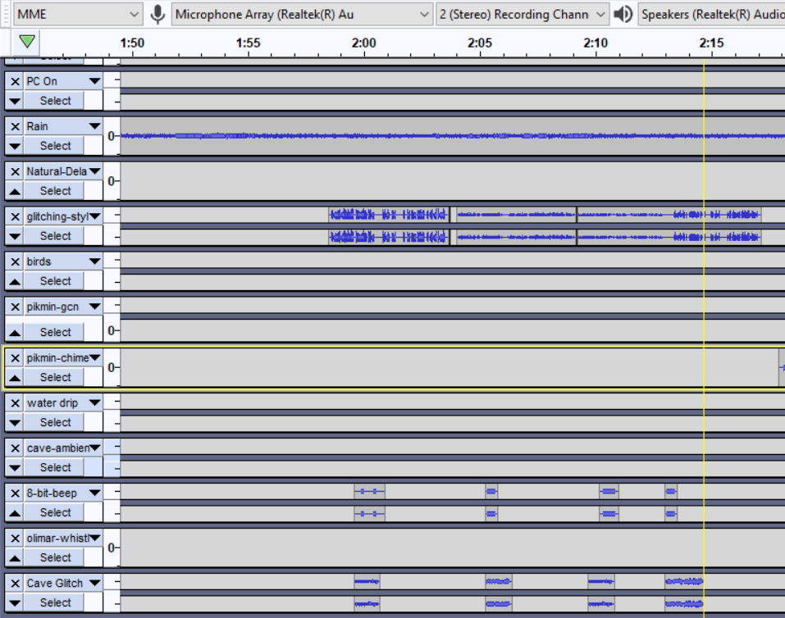

*Figure 2: Layered Sounds for Effect*

After receiving feedback, I changed the sounds of the “real world” from a bus ride to a thunderstorm I had personally recorded. For the computer-generated portion, I incorporated clips that resembled a glitching noise. I felt that incorporating sounds of nature would give the piece a more peaceful tone, while the computer noises gave the effect that something in the program was going wrong. One section of the piece I particularly enjoy is pictured in *Figure 2*, occurring near the end of the piece, from around 2:00 to 2:15. Here, I ended up layering several of the computer-generated sounds to coincide with the thunderstorm and overall chaotic feel, much different from the calmer beginning. Overall I enjoyed using sound effects to create a unique environment and narrative.